Prepositions of Concession

🔹 What Are Prepositions of Concession?
# Source: AI Source: Provided by: [Data Path: Persons Table -> ID Column: 1, Name_En Column: Motasem Essam] -> From: [Chatgpt (GPT-4-turbo)] on [7/28/2025]
Prepositions of concession show a contrast between two ideas — where one idea surprises, opposes, or happens despite another.
They answer the question:
👉 "Even though that happened, this still happened?"

✅ Common Prepositions of Concession
# Source: AI Source: Provided by: [Data Path: Persons Table -> ID Column: 1, Name_En Column: Motasem Essam] -> From: [Chatgpt (GPT-4-turbo)] on [7/28/2025]
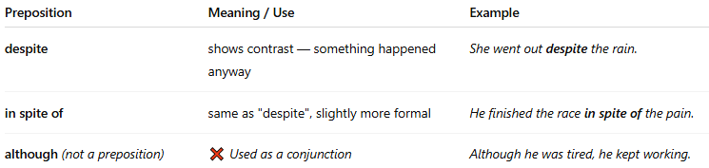
Preposition | Meaning / Use | Example
despite | shows contrast — something happened anyway | She went out despite the rain.
in spite of | same as "despite", slightly more formal | He finished the race in spite of the pain.
although (not a preposition) | ❌ Used as a conjunction | Although he was tired, he kept working.
⚠️ Note:
"Despite" and "in spite of" are true prepositions.
Words like "although" and "though" are conjunctions — not prepositions.

📚 Example Sentences
# Source: AI Source: Provided by: [Data Path: Persons Table -> ID Column: 1, Name_En Column: Motasem Essam] -> From: [Chatgpt (GPT-4-turbo)] on [7/28/2025]
- Despite the cold, they went swimming.
- In spite of her fear, she spoke on stage.
- Despite the noise, I managed to concentrate.

🧠 Quick Tip
# Source: AI Source: Provided by: [Data Path: Persons Table -> ID Column: 1, Name_En Column: Motasem Essam] -> From: [Chatgpt (GPT-4-turbo)] on [7/28/2025]
- ✅ Preposition → followed by a noun, pronoun, or gerund
→ despite the weather, in spite of being late
- ❌ Not followed by a full clause (don’t say: despite she was tired)

